Art- Alberto Giacometti  Make your own stickmen drawings.  Use tin foil from the kitchen to twist, turn, scrunch and roll a stickman.  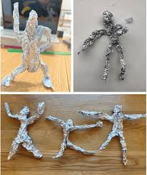 | Maths  Bonds to 20.  Use your toys at home-e.g Lego bricks/marbles/dolls/pens.  Use them to make bonds to 20 on tens frames that you have drawn or made with resources.  Write the number bonds on scrap paper next to the toys and upload photos to Tapestry.  Write your addition and subtraction bonds to and from 20. | English  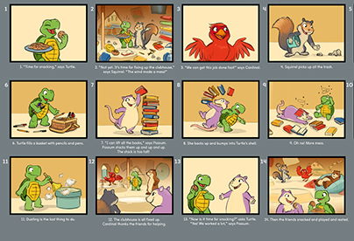  Make up your own story about a character who goes on a journey.
Junk Modelling  Use junk resources at home- cardboard tubes, boxes, paper.  Make a form of transport for your character in your story board. Imagine a journey. The boy can travel wherever you like! | Outdoor - Maths  What 3D shapes can you see in/ outside or around your house.  Draw pictures and label the shapes e.g.  Draw your lounge – a cube table. | PE - Dance  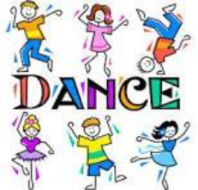  Film yourself on Tapestry.  Make up your own dance routine to a short piece of music. Think about the skills you have learnt in PE to include.
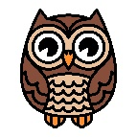
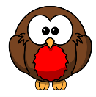
Spring 1 Homework Year Two

