At Biscovey Nursery and Infants’ Academy, we follow a whole school topic which changes annually. Each year group plans work for each subject at an appropriate level.
Autumn | Spring | Summer
Space | Traditional Tales  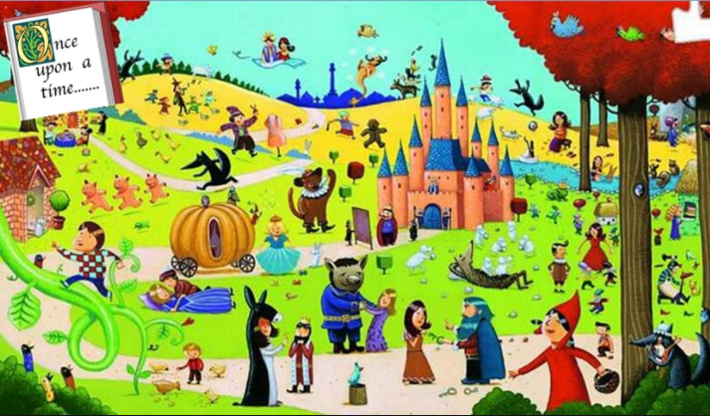 | The Sea

